**Experiment-2**

**Aim**:

To implement a CMOS inverter of level (1, 3 and 54) and analyse its dc characteristics.

**Tool Used:** LTspice software

**Theory:**

In CMOS technology, both N-type and P-type transistors are used to design logic functions. The same signal which turns ON a transistor of one type is used to turn OFF a transistor of the other type. This characteristic allows the design of logic devices using only simple switches, without the need for a pull-up resistor.

In CMOS inverter an n-type MOSFET acts as a pull-down transistor between the output and the low voltage power supply rail (Vss or quite often ground). Instead of the load resistor of Resistive Inverter, CMOS inverter has a p-type MOSFET in a pull-up transistor between the output and the higher-voltage rail (often named Vdd).

**Circuit Schematic: [ Level 1 ]**

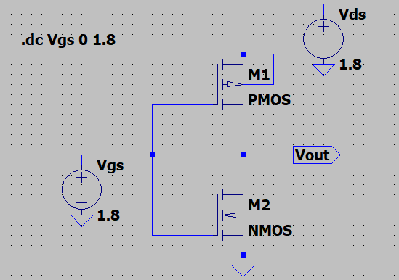

**Output Waveforms:**

Dc Transfer characteristics (Vgs vs. Vout)

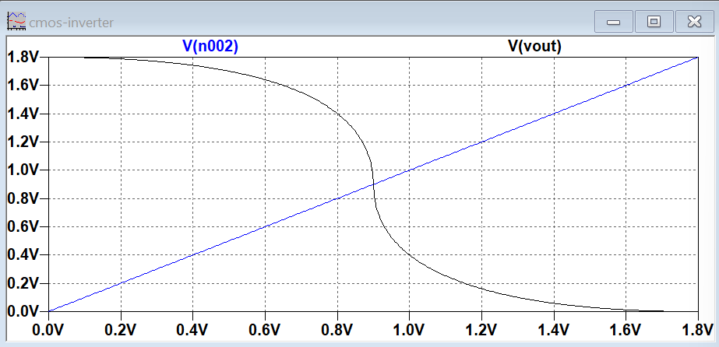

**Circuit Schematic: [ Level 3]**

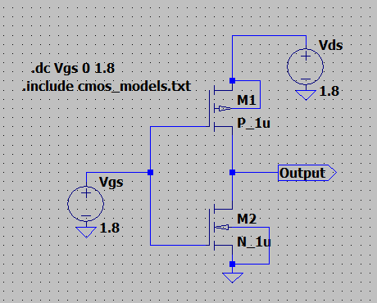

**Output Waveforms:**

Dc Transfer characteristics (Vgs vs. Vout) for (W/L)p / (W/L)n = 5

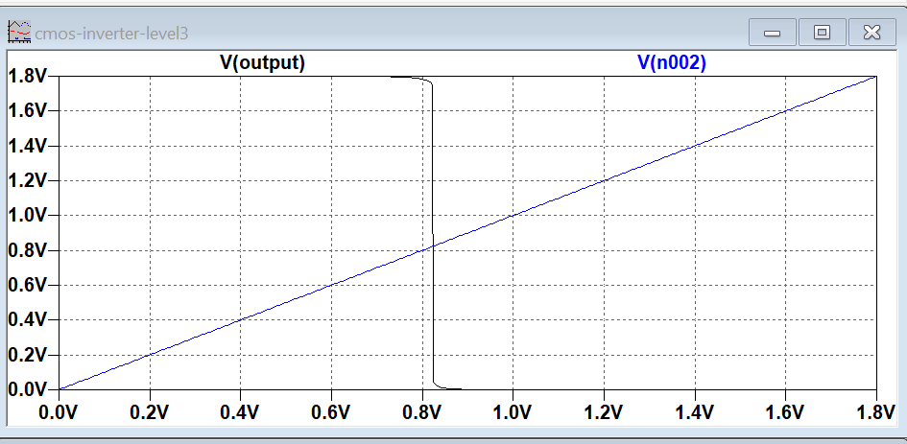

**Circuit Schematic: [ Level 54]**

­­­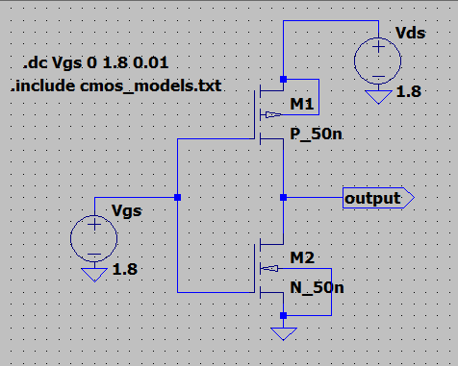

**Output Waveforms:**

Dc Transfer characteristics (Vgs vs. Vout) for (W/L)p / (W/L)n = 2.2

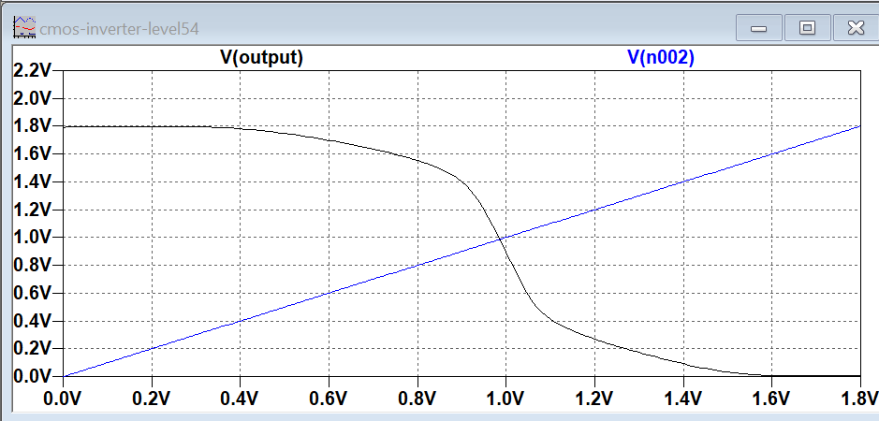

**Result:**

The circuit is stimulated for 3 levels of CMOS inverter and the dc characteristics are visualized.

­­